Git bash

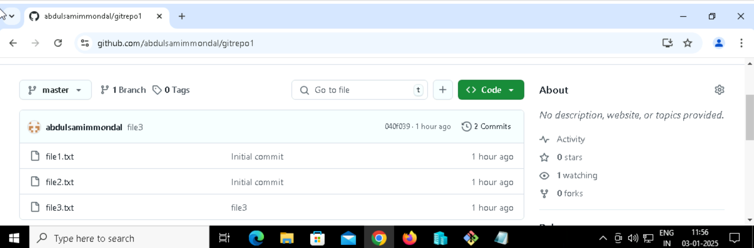

Git account